Silicon Carbide Inverter Solutions
Enabling Functionally Safe Drivetrain Design Using Certified Components
- Introduction
- The Need and Importance of Functional Safety in Automotive
- Why functional safety matters today more than ever (argument around EVs, carbon emissions, new levels of functionalities, and ADAS, etc.
- An overview of compliance standards (ISO 26262) and regulatory drivers
- ASIL Levels and their common understanding of what they mean for the drivers
- Inverter positioning in the overall vehicle system from a safety perspective
Due to growing concerns over climate change, the automotive industry is undergoing a transformative shift from fossil-based internal combustion to environmentally friendly intelligent electrification. Additionally, today’s vehicles are no longer regarded as merely the machines of mobility; rather, they tend to offer unprecedented functionality and user experiences ranging from improved fuel efficiency, reduced carbon emissions to sophisticated features like advanced driver assistance systems (ADAS) and smart infotainment. At the heart of this transformation lies a growing reliance on semiconductors, electronics, embedded systems, and software interfaces.
While on one hand, modern vehicles continue to offer enhanced features and support climate and energy goals, on the other hand, their complexity due to extensive integration of electronics and electrical systems also makes them more prone to failures and safety risks. If, due to any random hardware or software component failure, the vehicle does not perform its intended function, it might result in physical injury and damage. The goal of functional safety is therefore to make sure that the system is designed in such a way that, despite possible failure, damage can be prevented, or at least failure can be detected and controlled in a safe and predictive manner. Therefore, in recent years, there has been a lot of emphasis on functional safety implementation in applications, processes, and products. Accordingly, various industry standards have been defined for compliance. IEC 61508 is the generic functional safety standard for industry for electrical and electronic products from which many industry standards have been derived. Particularly, ISO 26262 deals with the functional safety of the automotive industry, which provides guidelines on:
- Hazards and Risks Assessment and their impact in terms of probability, severity, and controllability, collectively defined as automotive safety integrity levels (ASIL A, B, C, D), with ASIL D being the most critical in impact.
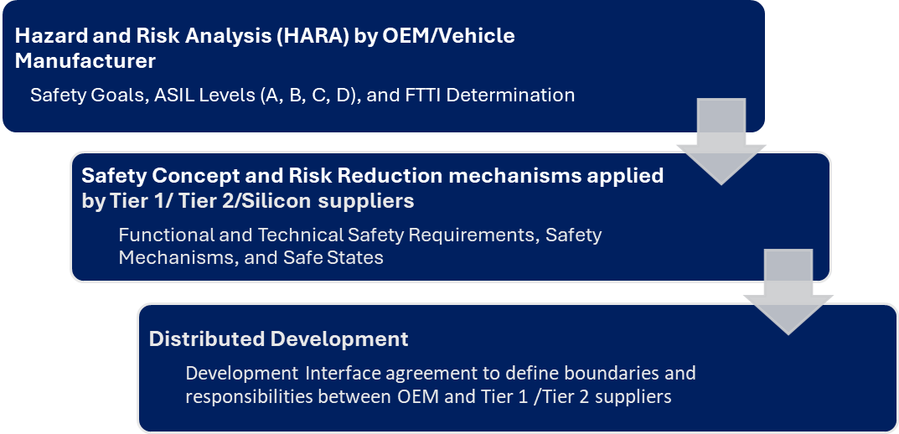
- Risk Mitigation Measures based on the safety concept, safety goals, safe states, and safety mechanisms.
- Development Interface Agreement for defining the safety boundaries and responsibilities of various stakeholders (OEMs, Tier 1/ Tier 2/ Silicon Suppliers) involved in the distributed development.
Modern vehicles have many subsystems (e.g., antilock braking, electric steering, lighting control, etc.); however, powertrain and inverter subsystems are central to vehicle propulsion and control. The key aspects of the driving experience, including acceleration, braking, and overall manoeuvrability and control of the vehicle, depend on the precise and predictable operation of the powertrain. Any fault in the inverter can lead to sudden loss of power, unwanted acceleration, or total motor shutdown, directly impacting the driver’s control over the car and potentially resulting in accidents, especially at high speeds or in critical situations, such as overtaking or lane changing. Therefore, the powertrain system, including inverters, must be reliable and fault-tolerant to ensure the safety of passengers, pedestrians, and other vehicles on the road. Designing functionally safe inverters is therefore not just good engineering; it’s essential for the trust, reliability, and future of next-generation vehicles. In line with this evolving market need, CISSOID offers a customizable, functionally safe inverter platform with a modular architecture and a complete product portfolio, including power modules, gate drivers, control boards, e-motor control software, and a fully functional reference design. Together, these elements provide a solid foundation for achieving functional safety in inverter applications, as explained in the remainder of the article.
- Understanding Functional Safety Requirements for an Automotive Inverter
- Main safety goals, torque, braking, and thermal requirements
- Introducing fault detection and safe states, and how to attain them
- What is needed (fast detection, preemption, and fast transition to a safe state)
- How the Intel + CISSOID solution has the potential to answer these challenges.
Functional safety of inverters is about proactively managing risks that stem from the hardware or software component failures in the Inverter. The OEM/Vehicle manufacturer performs a detailed hazard and risk analysis (HARA) based on which risks are identified, vehicle safety goals are defined, and ASIL levels are associated with each safety goal. ASIL A corresponds to the least stringent, while ASIL D corresponds to the most stringent requirement, depending upon the criticality of the safety goal violation. These goals generally include preventing unintended acceleration, unintended braking, unintended torque direction reversal, and fire/ thermal hazards under all operating conditions at ASIL C / ASIL D levels. Additionally, OEMs also define the fault-tolerant time interval (FTTIs) for each safety goal. This is the time within which a failure must be detected and the system must attain a safe state before the failure leads to a hazard.
These requirements on goals are passed to Tier 1/Tier 2/ Silicon suppliers, who are responsible for implementing the safety measures to fulfill these goals and thereby offer risk mitigation measures. At the Inverter manufacturer’s end, these vehicle safety goals are translated into Functional Safety Requirements (FSR) and Technical Safety Requirements (TSR) at the inverter level. Accordingly, an inverter Safety concept is derived, the core of which is based on the principle of fault detection via safety mechanisms, and reaction to put the inverter in a known safe state. The time intervals corresponding to fault detection and reaction (achieving a safe state) are termed as fault detection time interval (FDTI) and Fault reaction time interval (FRTI). Combinedly, the complete time interval of detection and reaction is termed as Fault handling time interval (FHTI) and must be lower than OEM-specified FTTI for each safety goal. For a three-phase power inverter, the safe state (SS) means stopping power flow from the source to the motor. This can be done by either turning OFF all SiC switches, known as All Open Circuit (AOC), or turning ON all SiC switches, known as Active Short Circuit (ASC). The choice of state depends on the motor speed.
Based on the above discussions, it is evident that achieving functional safety in modern vehicles is a complex process and it requires careful design of the safety concept, along with the implementation of fast, reliable, and configurable software and hardware safety mechanisms. However, this complexity can be substantially reduced by using certified hardware and software components. The key challenges to attain functional safety include careful design choices, ultra-fast detection and reaction, early failure mitigation, and quick transition to a safe state. The combination of Intel adaptive Inverter control application software with CISSOID inverter control module hardware effectively addresses these challenges and offers a powerful solution for fast control, reliable diagnostics, and strong functional safety. Thanks to its modular structure and built-in safety features, it is configurable according to the needs of OEMs, and it reduces the effort, time, and deep expertise typically required to develop a functionally safe system. By using this solution, OEMs and Inverter users can already come one step closer to achieving functional safety certification with greater ease and confidence.
- Modular solution Enabling Accelerated development and Functional Safety Compliance
- Intel Software safety features
- Intel Chip features
- ICM hardware safety features (gate driver features, DESAT, UVLO, etc, other interface circuits for filtering and protection)
- Overall Safety Concept [If needed, a figure of the ICM safety concept can be modified and added here from the safety manual]
- A few words about SIRD – how it enables accelerated development

To enable the fast-track powertrain development and achieve functional safety compliance with minimum complexity, CISSOID offers a modular hardware solution catering to the needs of OEMs and Powertrain developers at various levels. This includes a complete product range :
- Intelligent SiC power modules with robust and intelligent gate drivers with inherent protection and safety mechanisms (UVLO, DESAT, SSD, AMC, etc.) as shown in Fig. 1.
- ASIL-C ready Inverter Control module (ICM) with integrated ASIL-D certified Adaptive Control Unit (ACU) T222 by Intel Automotive offering state-of-the-art interfaces for automotive powertrain development including resolver/encoder, current/temperature sensors, CAN, high Voltage battery supply, SWD (debug) & Trace Port Unit (real-time debug & calibration) interfaces as shown in Fig. 2.
This solution can also be augmented by the ISO-26262 ASIL-D Adaptive Control App T222 Inverter software by​ Intel Automotive, supporting Field Oriented Control (FOC) and advanced modulation techniques (SVPWM, OPP), Gate driver and I/O Safety Interface, default, configurable and programmable custom safety fault detection and reaction for powertrain functional safety compliance as shown in Fig.4.
- The SiC Inverter Reference Design (SIRD), including ICM, DC-link Capacitor, EMI Filter, and Bleeder Circuit as a ready-to-use blueprint helping OEMs and Drivetrain makers to move quickly from concept to prototype without starting from scratch, with proven component integration and ease of functional safety compliance and certification as shown in Fig. 3.

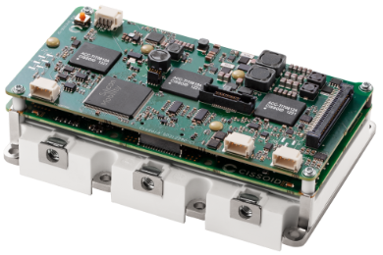
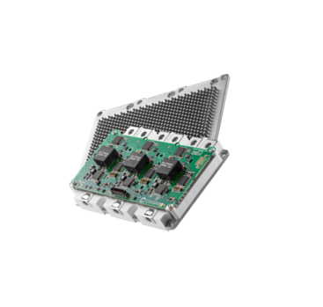
The functional safety in the inverter subsystem is enabled by the central safety manager, which keeps track of functional requirements (FRs) and safety requirements on each functional requirement (FSRs) through the following active safety mechanisms (SMs):
Figure 1 CISSOID Intelligent power module
- Ultra-fast digital comparators with configurable min/max thresholds to detect out-of-range (OoR) on important safety parameters, e.g.. phase currents, HVDC voltage, temperatures, etc. Thanks to the CISSOID control board sensing and filtering chain, along with the digital comparator available on ADCs in the ACU T222, any out-of-range anomaly can be detected in the order of 50 nanoseconds.
- Analog comparators available in the ACU T222 and SiC gate driver board to detect overcurrent, undervoltage, and Desaturation Faults.
- Thanks to the Adaptive Control App T222 Inverter software, configurable software safety mechanisms detect resolver faults, overspeed faults, over- and under-temperature, and over- and under-voltage for HVDC battery. These can be detected within the order of a few milliseconds.
- Safety digital IO to respond to critical faults signaled by an external digital input or VCU by EPIO diagnostics, thanks to ACU T222 can be detected in the order of 50 nanoseconds.
The redundancy in safety mechanisms allows achieving better ASIL levels at the vehicle level. Additionally, these safety mechanisms are user configurable, and they enable fast detection of failure and inform the safety manager to activate one of the safe states in case any failure occurs. Accordingly, a safe state PWM (AOC OR ASC) governs to control of the motor and puts the vehicle in a safe mode.
Figure 3: CISSOID SiC Inverter Reference Design
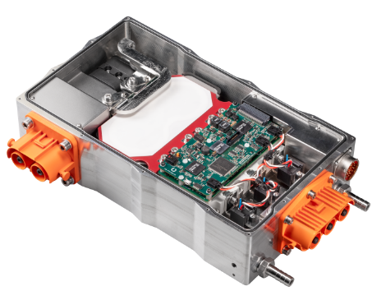
Figure 2: CISSOID SiC Inverter Control Module (ASIL-C Ready)
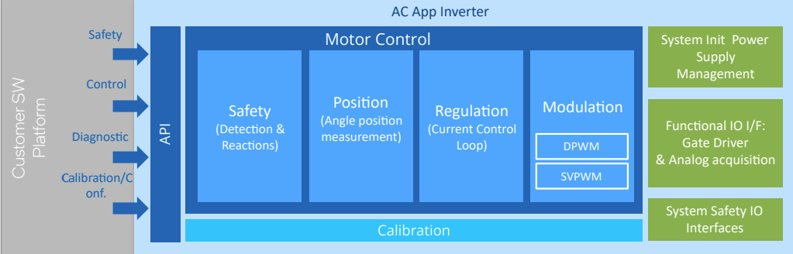
Figure 4: ASIL-D Certified Adaptive Control App T222 Inverter software by Intel Automotive
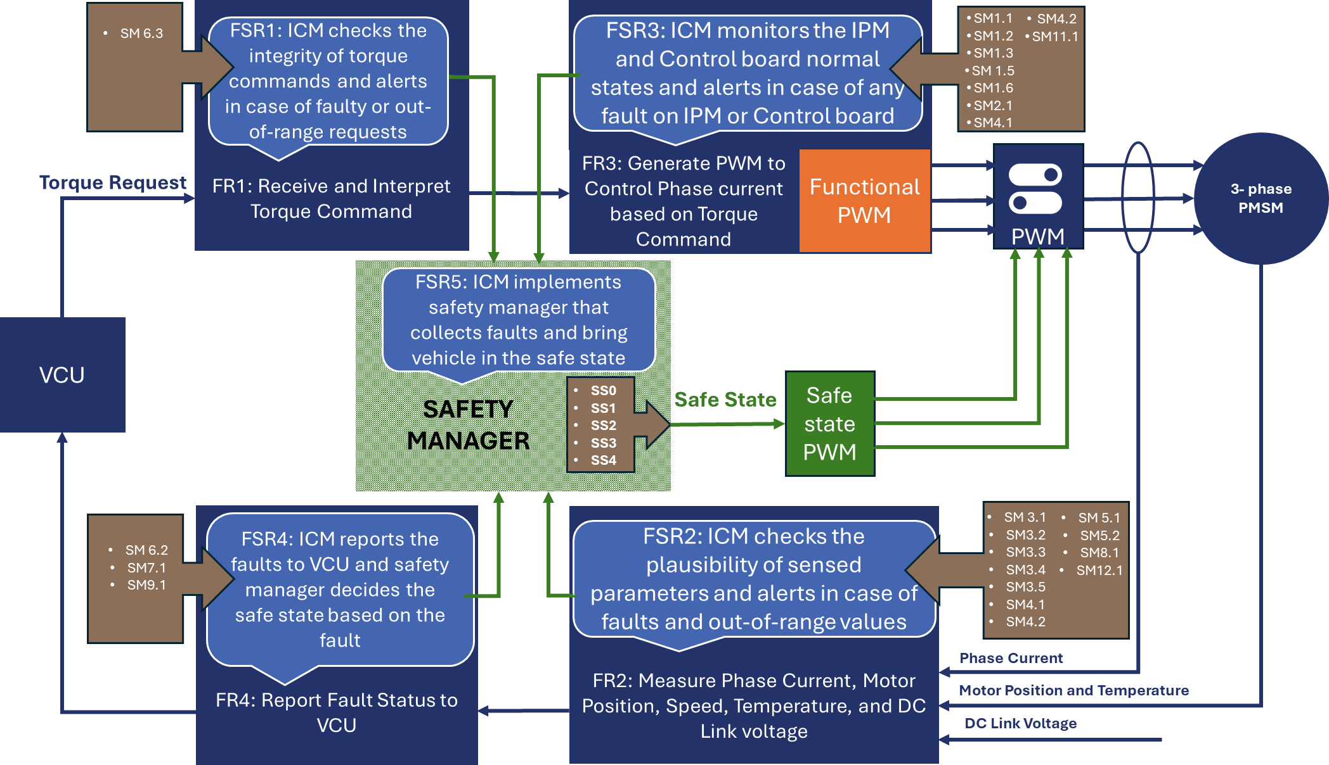
Figure 5: ICM Safety Concept in terms of functional requirements, functional safety requirements, Safety mechanisms, and Safe States.
- Case Study- CISSOID SiC ICM Functional safety compliance journey (a few words about SEooC, configurable FMEDA approach, safety manual describing the safety mechanisms, safe states, detection and reaction times, speed and voltage cases, etc.
For the functional safety compliance of ICM, CISSOID selected the most relevant vehicle safety goals through detailed discussions with OEM customers by understanding their needs and conducting extensive market research on automotive industry requirements. As a result, the inverter is treated as a Safety Element Out of Context (SEooC) in accordance to ISO26262 with the assumption that the vehicle level safety requirements are provided by the integrator. These safety goals, their ASIL levels, and the fault-tolerant time interval (FTTIs) are shown below.
Table 1Vehicle Safety Goals considered for ICM Functional Safety Readiness
ID | Title | FTTI | Target ASIL | Achieved ASIL
SG1 | Uncommanded accelerating torque shall be prevented  - From an idle situation, no uncommanded start of movement.  - From a running situation, no uncommanded acceleration. | 50 ms | D | D
SG2 | Uncommanded braking torque shall be prevented. | 50 ms | D | C
SG3 | Unexpected reversal torque shall be prevented  - From the idle position, if requested to accelerate in one direction, the vehicle should not go the other way.  - While running, if requested to increase the speed, the vehicle should not decrease the speed & vice versa | 50 ms | D | D
SG4 | Fire or thermal hazard shall be prevented | 100 ms | C | C
SG5 | Unintended loss of torque shall be prevented | 2000 ms | QM | C
A detailed failure mode, effects, and diagnostic analysis (FMEDA) for ICM is performed following ISO26262 guidelines and compiled in a configurable Excel spreadsheet. Failure modes of ICM components are analysed according to standards (IEC 61709, IEC 62380), and ICM Components’ basic FIT rates are calculated using SIEMENS' applied standard SN29500. The relevant safety information from ACU and Adaptive Control APP by Intel Automotive is also included in the configurable FMEDA file. For the typical mission profile specified by IEC62380, the results for ICM safety metrics for a low speed case are given below in Table 2.
SG | SPFM | LFM | PHMF | ASIL
SG 01 | 99.67% | 97.33% | 7.75 | ASIL-D
SG 02 | 99.24% | 87.71% | 20.22 | ASIL-C
SG 03 | 99.67% | 97.41% | 7.63 | ASIL-D
SG 04 | 99.46% | 88.97% | 15.17 | ASIL-C
SG 05 | 99.23% | 87.65% | 20.29 | ASIL-C
Overall ICM | 99.24% | 87.59% | 20.39 | ASIL-C
Table 2: Hardware Architectural Metrics for ASIL Determination (Case 1: Below Critical Speed)
- Development and Certification Support
- ASIL-Ready safety package introduction
- How CISSOID can help with safety analysis, a high-level view of how integrators can benefit from the safety package
- On-site support, active engineering design, and field application services
For OEMs and vehicle manufacturers looking for advancements toward functional safety compliance, CISSOID offers a comprehensive ASIL-Ready Safety Package designed to streamline the safety compliance journey. This package delivers more than just documentation, and it empowers integrators with valuable insights and tools to accelerate and simplify safety analysis for drivetrains and inverters. The comprehensive safety package includes a configurable FMEDA spreadsheet and safety manual, along with the presentation of key safety features in the CISSOID product range. OEMs and Vehicle manufacturers can use the configurable and modifiable FMEDA Excel spreadsheet and incorporate its results in their vehicle-level safety analysis based on their mission profile and battery voltage level. This will significantly reduce the efforts for performing vehicle-level FMEDA. Additionally, the detailed working and principles of various safety mechanisms, how to configure them, their FDTIs, information on safe states, their FRTIs, and overall FHTIs are also summarized in a dedicated safety manual and can be available for vehicle manufacturers for their vehicle-level safety analysis. Backed by CISSOID’s proven expertise in high-temperature SiC power module applications, active co-engineering, tailored on-site support, and dedicated field application services, customers also gain access to high-level safety frameworks, resulting in fast-tracking the development as well as seamless integration and compliance with ISO 26262 standards. For the customers using the ICM product, the functional safety compliance includes the following steps, where dedicated guidance, documentation, and co-engineering support are available for each step.

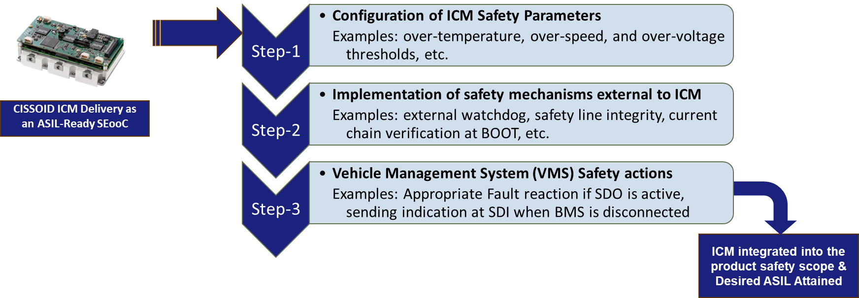
- Conclusion
- Achieving functional safety is complex but feasible with the right building blocks.
- CISSOID SIC solutions are the right trade-off between cost, complexity, efficiency, and safety.
- Extendibility and Adaptability to Further trends, Intel Software defined vehicles architecture, AI, OPP, etc.
Achieving functional safety is indeed a complex, time and resource-consuming process, but it becomes practical and manageable with the right building blocks. CISSOID’s SiC solutions, along with Intel Automotive software solutions, offer an ideal balance between cost, complexity, efficiency, and reliability for OEMs to meet the regulatory standards while reducing time-to-market. CISSOID’s modular SiC hardware platform with Intel automotive software solution is designed with future scalability in mind, offering the flexibility to adapt to evolving trends such as software-defined vehicle architectures, AI integration, and optimized pulse patterns (OPP) for enhanced efficiency and reliability. With CISSOID’s SiC solutions, vehicle manufacturers can meet today’s functional safety and regulatory requirements for their drivetrains, while also preparing their vehicles for future technologies and mobility trends.

