OLEA solution for inverter applications, now available as a booster to legacy platforms
OEMs and Tier1 face challenges in integrating disruptive technology in advanced electronics and powertrain components for EVs. Their system or software architecture platform legacy may be impacted inducing significant design effort to host the new piece of technology. The promise of performance improvement, BoM reduction and cost saving during production is mitigated by the adoption cost and the perception of the risk for a near future ROI is increased.
The OLEA® T222 FPCU and OLEA® APP – T222 INVERTER software enter into that category of the innovative technologies which offer a radical shift in inverter and e-motor performance improvement in regards to incumbent solutions: better efficiency, lower NVH, higher power density, less cooling need, small motor with same or high power, and more.
Up to now, OLEA® T222 FPCU was only usable as the main inverter controller, replacing conventional MCU, and the OLEA® APP – T222 INVERTER associated with an AUTOSAR (or custom) software platform selected by the user. Today, Silicon Mobility introduces the Auxiliary Function for OLEA® APP – T222 INVERTER that enable customers with the choice to keep their legacy software/system platform, to lower the integration effort and to benefit from the performance boost offered by the OLEA solution.
Versatility in integration:
The OLEA® APP – T222 INVERTER is an embedded software designed for the OLEA® T222 FPCU parallel architecture, enabling high-performance, real-time control inverter and electric motors. It offers efficient and safe control of torque, speed, current, and rotor using cutting-edge algorithms. This versatile software suits a wide range of powertrain systems, supports the latest technology inverters, and leverages parallel hardware for fast control loops and unprecedented energy efficiency gain with Optimized Pulse Patterns regulation. It also includes a separate functional safety stack and supports a model-based design flow for seamless integration.
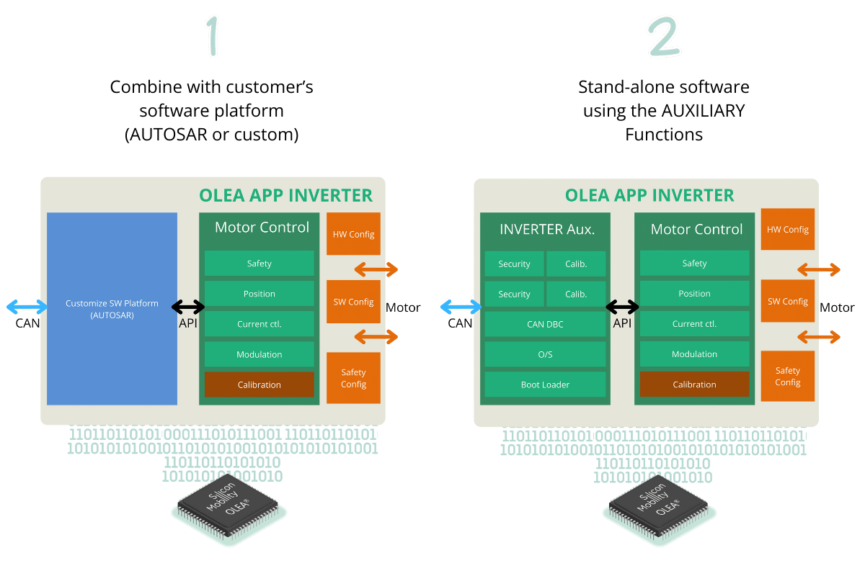
The OLEA® APP - T222 INVERTER can be used in two ways: either combined with a software platform (AUTOSAR or custom) embedded into the OLEA® T222 FPCU, or now, as a stand-alone software in the OLEA T222 FPCU using the Auxiliary Function component. The Auxiliary Function enable customers to preserve their existing software platform in a remote microcontroller of their choice reducing integration effort while keeping the legacy software platform and benefiting at the same time from the OLEA solution performance boost.

The Auxiliary Function is equipped with a suite of features designed to complement the motor control core functionalities. It includes a pre-emptive operating system, safety supervision, inverter management, diagnostic and EVITA light implementation for secure firmware updates. Among its features, it also integrates a CAN DBC messaging ensuring communication between OLEA T222 FPCU hosting OLEA APP - T222 INVERTER and a remote microcontroller hosting the customer's software platform enabling seamless integration of the OLEA solution in a legacy platform.

Opting for the Auxiliary Function
By opting for the Auxiliary Function, OLEA can serve in two different ways. Firstly, it can function as a companion chip or booster, operating the OLEA® APP – T222 INVERTER + Bridge over CAN configuration. In this role, it is perceived as a Complex Device Driver for the AUTOSAR SW platform, seamlessly integrating with the microcontroller running the customer's AUTOSAR SW platform. When both the MCU and OLEA share the same board, their direct connection via CAN enables safety integration optimization and removing the need for a separate SBC.
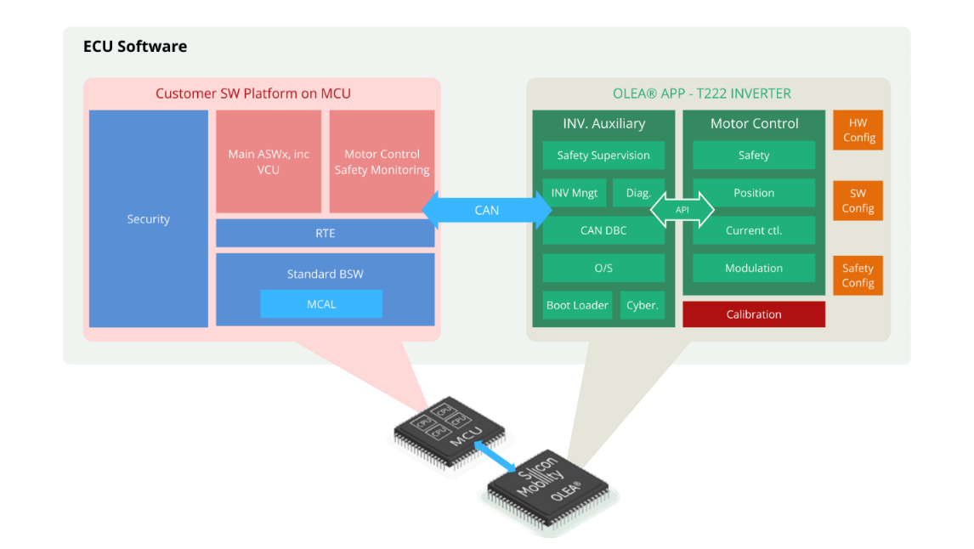
Alternatively, OLEA can be employed as a slave inverter controller, running the OLEA® APP – T222 INVERTER + ridge over CAN setup. In this capacity, it is viewed as a remote inverter controller, with speed and torque commands transmitted by a central VCU/VDU and the status and safety information collected by the same central VCU/VDU.
Numerous Benefits:
The advantages of integrating the OLEA technology as a companion chip into an automotive architecture are numerous. Here are some of the top key benefits in a specific use case:
- 100% energy efficiency / NVH gains from OLEA® solution
- Use existing and fully validated software
- ISO 26262 ASIL-D certified and EVITA Light compliant
- BoM Optimization:
  - + 1 OLEA FPCU, but
  - No Watchdog PSBC,
  - No glue logic redundancy (e.g Active Short Circuit)
  - Usage of simpler/cheaper MCU
  - Usage of cheaper power devices
  - System cooling reduction
- NRE reduction:
  - No new AUTOSAR stack sourcing
  - No new cybersecurity stack sourcing
  - Most of the functional safety architecture remains unchanged

Get started right away!
Customers can get immediate hands-on experience with our OLEA® APP – T222 INVERTER. It allows testing and evaluation while enabling fast prototyping and development. This can be done under our evaluation kits or using our partnered solutions. Either way, using these starting kits allows you to start getting your first data in a couple of weeks.
Please contact our sales team contact@silicon-mobility.com.

